1.**OPTIMIZATION**

The optimization and vibration frequency labeling of CCPE are performed on the "*aminomethanol*" molecule, as shown in **Fig. 1**, as described below.

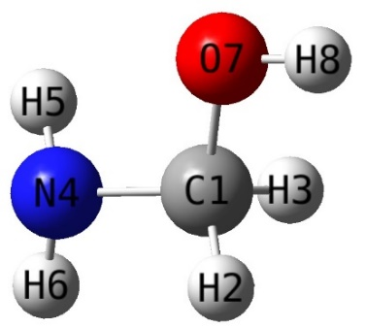

**Figure 1.** The optimized structure of aminomethanol compound calculated by DFT/B3LYP and 3-21G basis set.

1. To organize the optimization data calculated with the Gaussian program:

1. The optimization option is selected from the input interface of CCPE, as shown in **Fig. 2**.

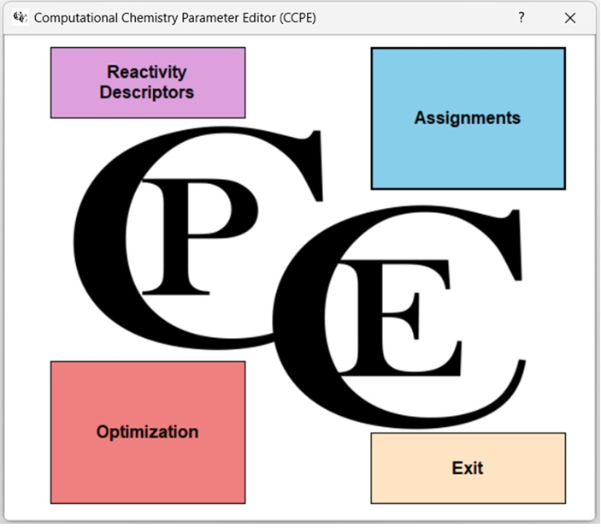

**Figure 2**. Input interface of the CCPE tool

1. From the opened window, the “*filename.log*” file is directly called from the Gaussian software output file. Thus, the optimization parameters and atoms in the compound from the output.log file are listed in a numbered format on the program, as shown in **Fig. 3**. When "Generate" is selected, the optimized parameters of aminomethanol will be neatly listed in the window on the right.

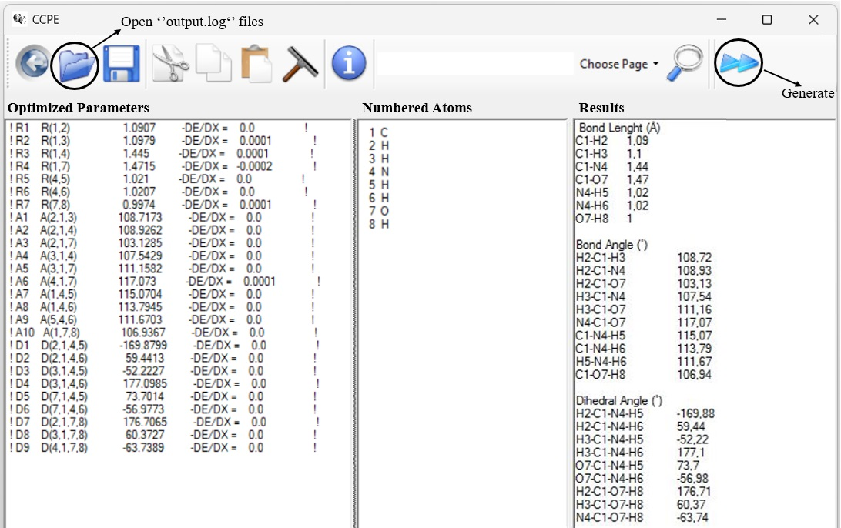

**Figure 3.** Optimization tab of the CCPE software for a) optimization parameters, b) atoms corresponding to the numbers and c) results.

2. **ASSIGNMENT**

VEDA is a highly useful software for labeling frequency calculation output files from the Gaussian program. To organize the results obtained from VEDA’s output files, the "Assignment" option is selected from CCPE’s input interface.

In the opened interface:

1. The blue file icon is clicked to select a “*filename.vdf*” file, one of the VEDA output files.
2. The yellow file icon is clicked to select another “*filename.dd2*” file from the VEDA output files.  
   Thus, the data extracted from both files will be listed in the interface. After selecting "Generate," the data will be processed, and the vibration frequency labels for aminomethanol will be neatly listed in the window on the right (**Fig. 4**).

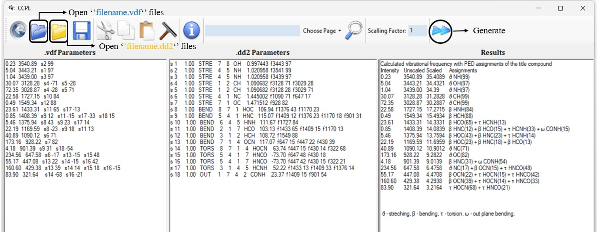

**Figure 4.** Assignment tab of the CCPE software, **a)** contributions to each vibration mode, **b)** content of contributions and **c)** edited output.

3. **MOLECULAR ORBITAL PARAMETERS**

In the output file generated by GAUSSIAN, the HOMO-LUMO orbital energies are provided in atomic units (a.u.), while some other programs may provide these energies in electron volts (eV). CCPE enables the easy calculation of the relevant parameters for both cases. To calculate the HOMO-LUMO and related parameters for a compound obtained from the GAUSSIAN software, the 'Reactivity Descriptors' option is first selected from the main page of CCPE. After entering the HOMO-LUMO energy values in the opened window, the unit of the entered value should be specified, and by selecting the 'Generate' option, the results will be listed in a publication-ready format (in eV) (**Fig. 5**).

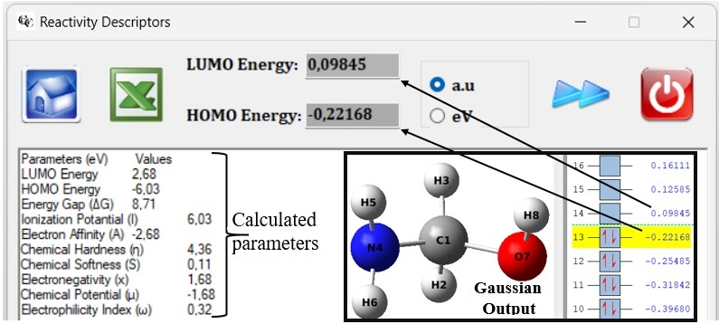

**Figure 5.** Reactivity descriptors window of the CCPE software